ST. KATHARINE’S C.E. (V.A.) PRIMARY SCHOOL
Rolls Drive · Southbourne · Bournemouth BH6 4NA

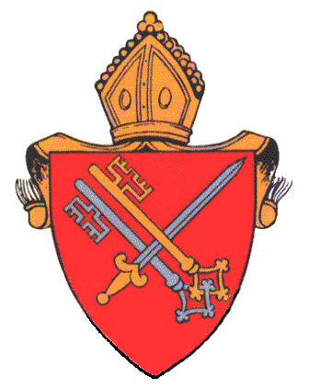
INFECTION AND ILLNESS GUIDE

Illness | Recommended period to be kept away from school | Comments
Diarrhoea and/ or Vomiting | 48 hours from last episode of diarrhoea or vomiting. | Exclusions from swimming should be 2 weeks following the last episode of diarrhoea.
Athletes Foot | None. | Athletes foot is not a serious condition. Treatment is recommended.
Chickenpox* | 5 days from onset of rash. | See: female contacts – pregnancy.
Cold Sores | None. | Avoid contact with the sores. Cold sores are generally a mild self-limiting disease.
Conjunctivitis | None.
Impetigo | Until lesions are crusted or healed. | Antibiotic treatment by mouth may speed healing and reduce infectious period.
Molluscum Contagiosum | None. | A self-limiting condition.
Ringworm | Until treatment commenced. | Treatment is important and available from the pharmacy.  N.B For ringworm of scalp treatment by GP is required.  Also check and treat symptomatic pets.
Scabies | Child can return after first treatment. | Two treatments one week apart for cases.  Contacts should have one treatment; include the entire household and any other very close contacts.
Slapped Cheek*  (Fifth Disease/ Parvovirus B19) | None. | See: Female contacts – pregnancy
Shingles* | Exclude only if rash is weeping and cannot be covered. | Can cause chickenpox in those who are not immune. i.e. have not had chickenpox. It is spread by very close contact and touch.  See: female contacts – pregnancy.
Warts and Verrucae | None. | Verrucae should be covered in swimming pools, gymnasiums and changing rooms.
Glandular Fever | None. | About 50% of children get the disease before they are 5 and many adults also acquire the disease without being aware of it.
Head Lice | None. | Treatment is recommended only in cases where live lice have been seen. Close contacts should be checked and treated if live lice are found. Regular detection combing should be carried out by parents.
Threadworms | None. | Treatment is recommended for the child and household contacts.
Tonsillitis | None. | There are many causes, but most are due to viruses and do not need an antibiotic.
Hand, Foot and Mouth | None.

*Female contacts – pregnancy

- If a pregnant woman develops a rash or is in direct contact with someone with a potential infectious rash this should be investigated by a doctor.

- Information taken from the Health Protection Agency’s Guidelines on Infection Control in Schools and other Care Settings.

